Arca Continental Ecuador and Coca-Cola Ecuador Strengthen Their Presence in Ecuadorian Sports with Liga Deportiva Universitaria

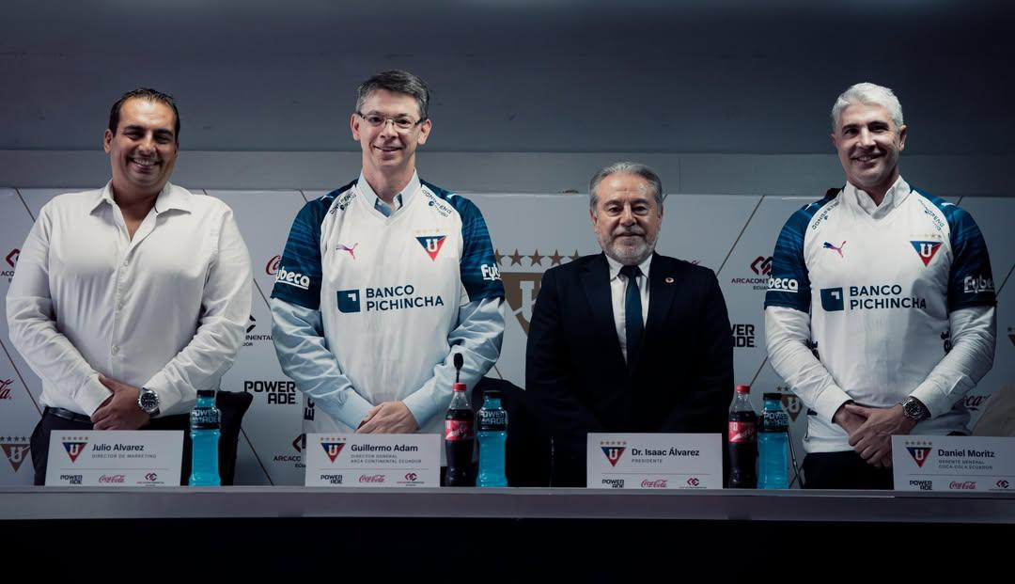
From left to right: Julio Álvarez, Marketing Manager of Liga Deportiva Universitaria; Guillermo Adam, General Director of Arca Continental Ecuador; Dr. Isaac Álvarez Granda, President of Liga Deportiva Universitaria; and Daniel Moritz, General Manager of Coca-Cola Ecuador.
Quito, June 2026. – Arca Continental and Coca-Cola Ecuador strengthen their relationship with Liga Deportiva Universitaria, one of the most emblematic institutions in the country, to continue growing together through the passion that unites us: football. This alliance reflects shared values such as discipline, teamwork, and commitment, connecting people, communities, and our culture.
This agreement includes the use of the club’s brand and image, as well as presence in official spaces such as matches, training sessions, and press conferences.
“There are partnerships that are born to make history. Today, we welcome a new partner on our journey. Together with Arca Continental Ecuador, Coca-Cola, and Powerade, we share the commitment to continue being present in every emotion, every celebration, and every moment with our fans,” said Dr. Isaac Álvarez, President of Liga Deportiva Universitaria.
As part of this initiative, Coca-Cola and Powerade—the official sports drink of the FIFA World Cup 2026™—will strategically support the team, strengthening its preparation, hydration, and performance both on and off the field.
“This alliance reflects our conviction that sports are a powerful tool for creating value, strengthening bonds with communities, and inspiring new generations. At Arca Continental, together with our partner Coca-Cola, we will continue to invest in initiatives that contribute to the development of sports and the progress of the country,” said Guillermo Adam, General Director of Arca Continental Ecuador.
For his part, Daniel Moritz, General Manager of Coca-Cola Ecuador, highlighted:
“For Coca-Cola and Powerade, football plays a very important role. It is a space where we want to be, and where we have been alongside Ecuadorians for nearly 100 years, sharing moments of joy, unity, and excitement. Coca-Cola has been part of those moments when fans come together and celebrate, while Powerade supports the preparation, discipline, and effort of athletes. That is why partnerships like this with Liga Deportiva Universitaria allow us to stay close to fans, their passion, and those moments where the emotion of football is lived from the heart.”
Through this agreement, Arca Continental Ecuador, Coca-Cola, and Powerade reaffirm their commitment to Ecuadorian sports, helping inspire new generations both on and off the field.

Photo Gallery:
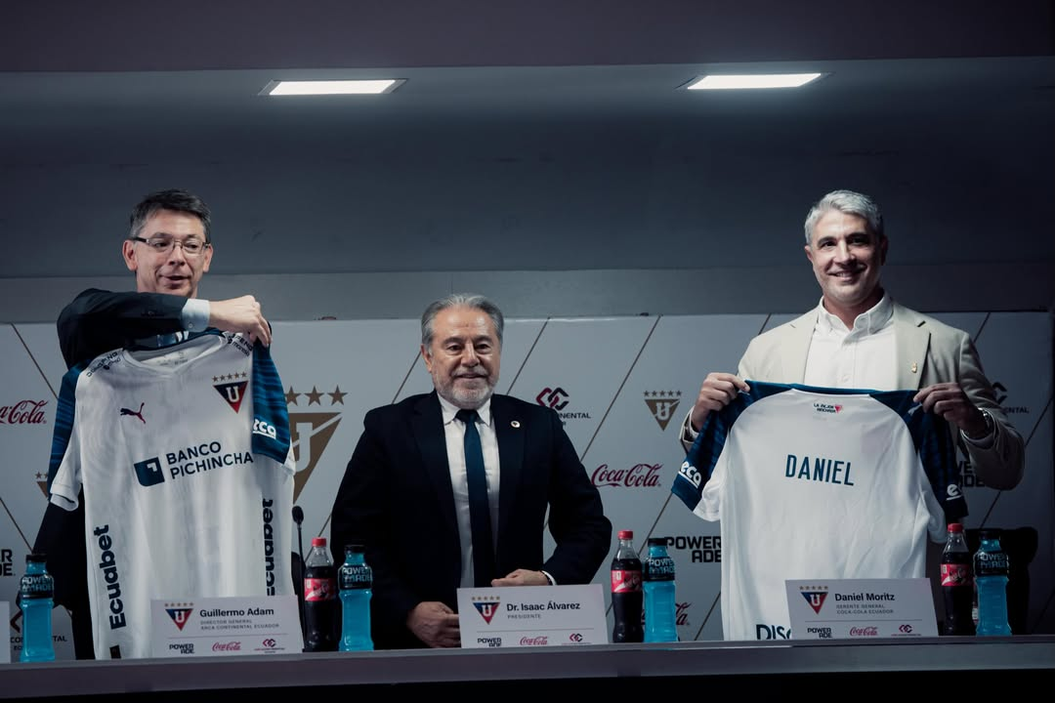
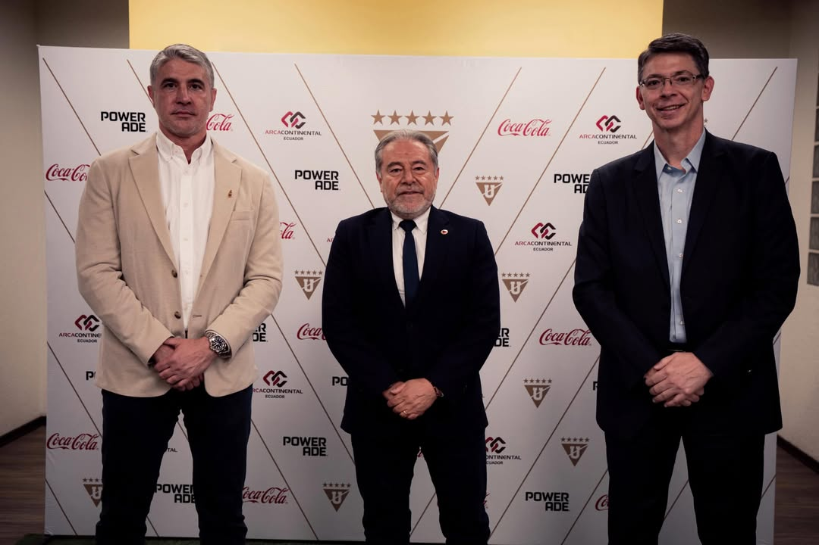

About Arca Continental

Arca Continental is a company dedicated to the production, distribution, and sale of beverages under brands owned by The Coca-Cola Company, as well as snacks under the Bokados brand in Mexico, Inalecsa in Ecuador, and Wise in the United States.
With a distinguished history of more than 100 years, Arca Continental is the second-largest Coca-Cola bottler in Latin America and one of the most important worldwide. Within its Coca-Cola franchise, the company serves a population of more than 125 million people across northern and western Mexico, Ecuador, Peru, northern Argentina, and the southwestern region of the United States.
Arca Continental is listed on the Mexican Stock Exchange under the symbol “AC.” For more information, please visit: www.arcacontal.com

About The Coca-Cola Company
The Coca-Cola Company (NYSE: KO) is a total beverage company whose products are sold in more than 200 countries and territories. Our purpose is to refresh the world and make a difference.
We sell multiple billion-dollar brands across several beverage categories worldwide. Our portfolio of sparkling soft drink brands includes Coca-Cola, Sprite, and Fanta. Some of our hydration, sports, coffee, and tea brands include Dasani, SmartWater, vitaminwater, Topo Chico, BODYARMOR, Powerade, Costa, Georgia, Gold Peak, Honest, and Ayataka. Our nutrition, juice, dairy, and plant-based beverage brands include Minute Maid, Simply, innocent, Del Valle, fairlife, and AdeS.
For more information, visit www.coca-colacompany.com and follow us on Instagram, Facebook, and LinkedIn.

Contact
Sofía Daniela Sierra
Communications and Sustainability Manager – Arca Continental
📞 +593 99 348 4990
✉️ sofia.sierra@arcacontal.com
Paola Palacios
Senior Manager, Public Affairs, Communications, and Sustainability
📞 +593 99 352 9552
✉️ ppalacios@coca-cola.com

